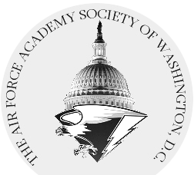 | 8th Annual USAFA Founders Day Golf Tournament  For the Benefit of the AFASW and USAFA Endowment

20 April 2018 - Andrews AFB South Course
Open to graduates and friends of the Academy

0930 hrs shotgun start
Scramble format – Captain’s Choice
BBQ Buffet to follow

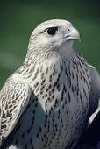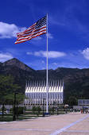

Individual Entry Fee – $150/person

Sponsor a Hole – $350 donation
Includes sign and one tee time
Tournament Sponsor – $1,000 donation Includes premium signage and four tee times
Polaris Sponsor – $2,500 donation Includes premium signage and eight tee times
Title Sponsor – $5,000 donation Includes title signage and twelve tee times

Save the date! Signup instructions will be provided in early 2018.
Questions or inquiries regarding sponsorship: Contact Jim Thompson @ 202.288.8736 – jethompson01@gmail.com

